



# Incident Response Platform Integrations

# QRadar Advisor Integration Function V2.0.0

Release Date: March 2019

Resilient Functions simplify development of integrations by wrapping each activity into an individual workflow component. These components can be easily installed, then used and combined in Resilient workflows. The Resilient platform sends data to the function component that performs an activity then returns the results to the workflow. The results can be acted upon by scripts, rules, and workflow decision points to dynamically orchestrate the security incident response activities.

This guide describes the QRadar Advisor Integration Function.

Overview

Backed by IBM Watson, QRadar Advisor applies artificial intelligence to automatically investigate indicators of compromise (IOC), utilizes cognitive reasoning to provide critical insights, and ultimately accelerates the response cycle. It can augment a security analyst to gain a head start in assessing incidents and reduce the risk of missing threats.

QRadar Advisor Integration Function enables Resilient users to gather Cyber Threat Intelligence(CTI) data from IBM Watson and QRadar. This information is critical for effective identification of potential IOC and quick response to incidents. In addition, this integration receives MITRE ATT&CK information from QRadar Advisor. As a result, an example workflow of this integration depends on the MITRE ATTACK function integration.

QRadar Advisor integration includes four functions:

* Perform a Watson Search on an indicator and retrieve suspicious observables related to it.
* Perform a Watson Search with Local Context on an indicator and retrieve a cyber threat intelligence (CTI) report on it in Structured Threat Information eXpression ([STIX2](https://stixproject.github.io/)) format.
* Perform an analysis on a QRadar offense, and retrieve CTI data from QRadar Advisor and IBM Watson in STIX format.
* Map a given QRadar rule to MITRE ATT&CK tactics.

The package also includes workflow examples to demonstrate the usage of the above functions.

The remainder of this document describes the functions and how to configure them in custom workflows or using the configuration file.

Installation

Before installing, verify that your environment meets the following prerequisites:

* Resilient platform is version 30 or later.
* You have a Resilient account to use for the integrations. This can be any account that has the permission to view and modify administrator and customization settings, and read and update incidents. You need to know the account username and password.
* You have access to a Resilient integration server. An *integration server* is the system that you use to deploy integration packages to the Resilient platform. See the [Resilient Integration Server Guide (PDF)](https://github.com/ibmresilient/resilient-reference/blob/master/developer_guides/Integration%20Server%20Guide.pdf) for more information.

QRadar Advisor Configuration

You need to have QRadar Advisor installed to a QRadar server, and fully configured, as shown in the following configuration page.

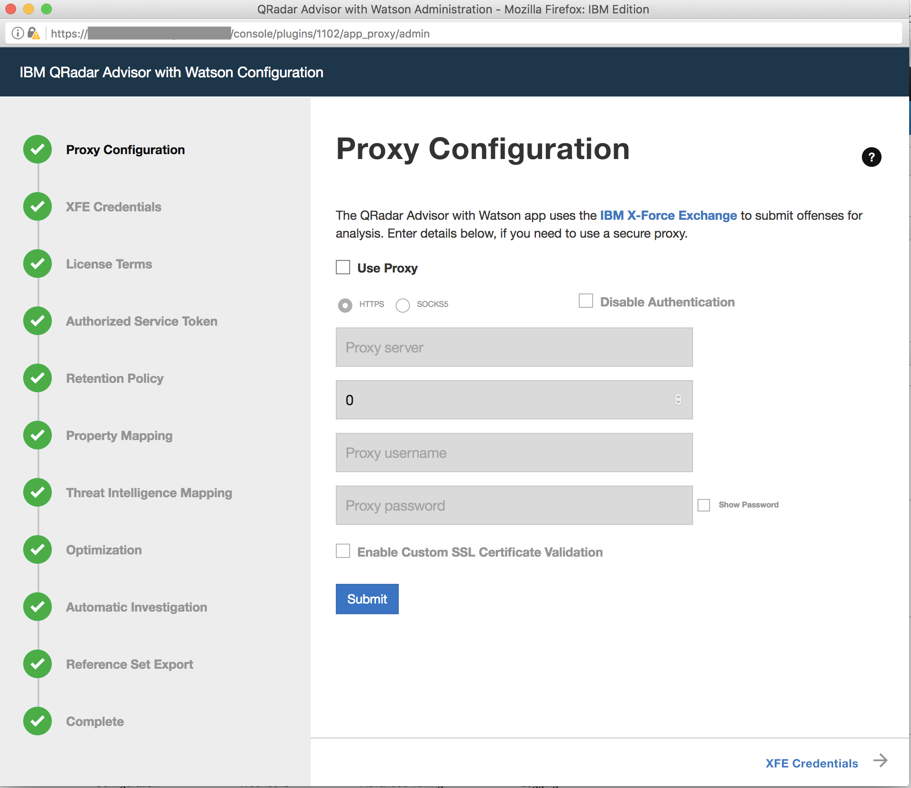

To access the QRadar Advisor REST API, you need to know its app_id, which you can access by clicking the QRadar Advisor’s Configuration icon. For example, in the URL address shown in the configuration page screenshot, the app_id is 1102 for this QRadar Advisor instance.

You also need an access token to use the REST API. You can obtain access tokens from the Authorized Service Token section of the Admin page.

Cyber Adversary Framework Mapping Application Configuration

QRadar Advisor 2.0 comes with Cyber Adversary Framework Mapping Application (CAFM). This needs to be properly configured as well. From the Admin page of QRadar, select the Configuration page for CAFM. Click the configuration button on the top right corner, and then enter an authorization token. This token can be the same as the authorization token used for QRadar Advisor above.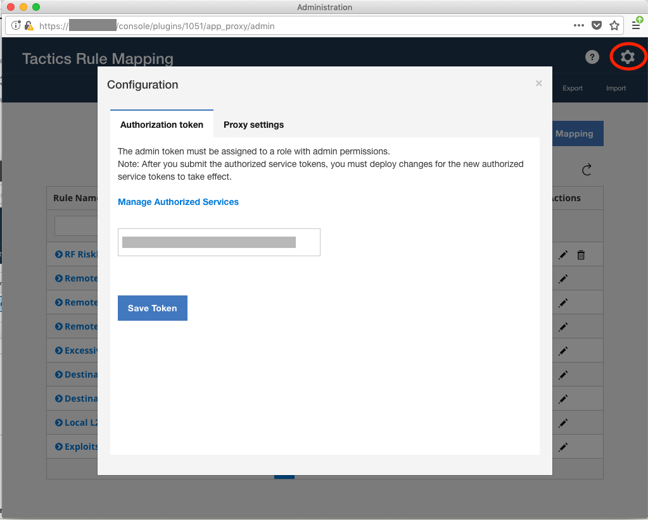

Write down the app id for CAFM. It is shown in the URL address of this page. For the example above, the app id for CAFM is 1051. This app id is needed in the app.config file.

Install the Python components

The functions package contains Python components that are called by the Resilient platform to execute the functions during your workflows. These components run in the Resilient Circuits integration framework.

The package also includes Resilient customizations that will be imported into the platform later.

Complete the following steps to install the Python components:

1. Ensure that the environment is up-to-date, as follows:

sudo pip install --upgrade pip

sudo pip install --upgrade setuptools

sudo pip install --upgrade resilient-circuits

1. Run the following command to install the packages:

sudo pip install –-upgrade fn_mitre_integration-<version>.<zip>

sudo pip install --upgrade fn_qradar_advisor-<*version*>.<zip>

Configure the Python components

The Resilient Circuits components run as an unprivileged user, typically named integration. If you do not already have an integration user configured on your appliance, create it now.

Complete the following steps to configure and run the integration:

1. Using sudo, switch to the integration user, as follows:

sudo su - integration

1. Use one of the following commands to create or update the resilient-circuits configuration file. Use –c for new environments or –u for existing environments.

resilient-circuits config -c

or

resilient-circuits config -u

1. Edit the resilient-circuits configuration file, as follows:
   1. In the [resilient] section, ensure that you provide all the information required to connect to the Resilient platform.
   2. In the [fn_qradar_advisor] section, edit the settings as follows:

qradar_host=host of your QRadar server with QRadar Advisor installed

qradar_advisor_token=qradar token (res-keyring protected recommended)

qradar_advisor_app_id=qradar app id for qradar advisor

verify_cert=[true|false] whether to validate the QRadar server cert

﻿qradar_cafm_token=qradar token (res-keyring protected recommended)

qradar_cafm_app_id=qradar app id for CAFM

#optional settings

full_search_timeout=timeout for full search in seconds (1200 default)

full_search_period=period for full search in seconds (5 default)

offense_analysis_timeout=timeout for analysis in seconds (1200 default)

offense_analysis_period=period for analysis in seconds (5 default)

1. (Recommended) Use res-keyring to store the qradar advisor token:
   1. Instead of storing your token in plaintext, use this instead in your app.config for the token

qradar_advisor_token=^qradar_advisor_token

qradar_cafm_token=^qradar_cafm_token

* 1. Now run the following command from a terminal in the same folder of your app.config

res-keyring

* 1. Follow the prompt to enter your token

Deploy customizations to the Resilient platform

This package contains four function definitions and includes example workflows and rules that invoke those functions. Note that the last two workflows below (“Example of mapping QRadar rule to tactic” and “Example of QRadar Advisor Offense Analysis”) both call a function from the MITRE ATTACK integration.

|  |  |  |
| --- | --- | --- |
| **Function** | **Example Workflow** | **Rule** |
| Watson Search | Example of Watson Search | Watson Search |
| Watson Search with Local Context | Example of Watson Search with Local Context | Watson Search with Local Context |
| QRadar Advisor Offense Analysis | Example of QRadar Advisor Offense Analysis | QRadar Advisor Offense Analysis |
| QRadar Advisor Map Rule | Example of mapping QRadar rule to tactic | Map rule to MITRE tactic |

In addition, the package contains five custom data tables. Two are called “QRadar Advisor analysis results” and “Watson Search with Local Context results”. They are used by the example workflows to show the observables that are extracted from the QRadar Advisor STIX response. Two demo scripts and two associated rules are also included. Each rule is a menu item added to its own data table. The user can click on a rule to create an artifact based on the selected row.

|  |  |  |
| --- | --- | --- |
| **Data Table** | **Rule** | **Script** |
| QRadar Advisor analysis results | Create Artifact (QRadar Advisor Analysis) | Create Artifact for QRadar Advisor Analysis Observable |
| Watson Search with Local Context results | Create Artifact (Watson Search with Local Context) | Create Artifact for Watson Search with Local Context |

The other three data tables are “MITRE ATTACK of artifact”, “MITRE ATTACK of incident”, and “MITRE ATTACK techniques”. They are used to by the example workflows to show MITRE ATTACK tactics and techniques related to an incident or artifact.

|  |  |  |
| --- | --- | --- |
| **Data Table** | **Rule** | **Workflow** |
| MITRE ATTACK of artifact | Map rule to MITRE tactic | Example of mapping QRadar rule to tactic |
| MITRE ATTACK technique | Create task for technique | Example of adding MITRE tech task |

Note the “Example of adding MITRE tech task” is a workflow included in the MITRE ATTACK integration.

1. Use the following command to deploy these customizations to the Resilient platform:

resilient-circuits customize

1. Respond to the prompts to deploy functions, message destinations, workflows, scripts, and rules.

Run the integration framework

To test the integration package before running it in a production environment, you must run the integration manually with the following command:

resilient-circuits run

The resilient-circuits command starts, loads its components, and continues to run until interrupted. If it stops immediately with an error message, check your configuration values and retry.

Configure Resilient Circuits for restart

For normal operation, Resilient Circuits must run continuously. The recommended way to do this is to configure it to automatically run at startup. On a Red Hat appliance, this is done using a systemd unit file such as the one below. You may need to change the paths to your working directory and app.config.

1. The unit file must be named resilient_circuits.service To create the file, enter the following command:

sudo vi /etc/systemd/system/resilient_circuits.service

1. Add the following contents to the file and change as necessary:

[Unit]  
Description=Resilient-Circuits Service  
After=resilient.service  
Requires=resilient.service

[Service]  
Type=simple  
User=integration  
WorkingDirectory=/home/integration  
ExecStart=/usr/local/bin/resilient-circuits run  
Restart=always  
TimeoutSec=10  
Environment=APP_CONFIG_FILE=/home/integration/.resilient/app.config  
Environment=APP_LOCK_FILE=/home/integration/.resilient/resilient_circuits.lock

[Install]  
WantedBy=multi-user.target

1. Ensure that the service unit file is correctly permissioned, as follows:

sudo chmod 664 /etc/systemd/system/resilient_circuits.service

1. Use the systemctl command to manually start, stop, restart and return status on the service:

sudo systemctl resilient_circuits [start|stop|restart|status]

You can view log files for systemd and the resilient-circuits service using the journalctl command, as follows:

sudo journalctl -u resilient_circuits --since "2 hours ago"

Function descriptions

Once the function package deploys the functions, you can view them in the Resilient platform Functions tab, as shown below. [Need to update screenshot with new functions from both packages]

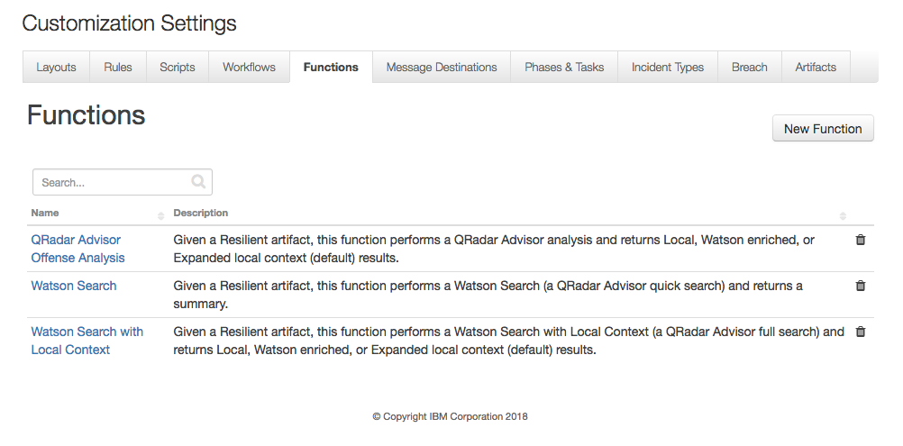

The package also includes example workflows and rules that show how the functions can be used. You can copy and modify these workflows and rules for your own needs. [Need to update screenshot with both packages]

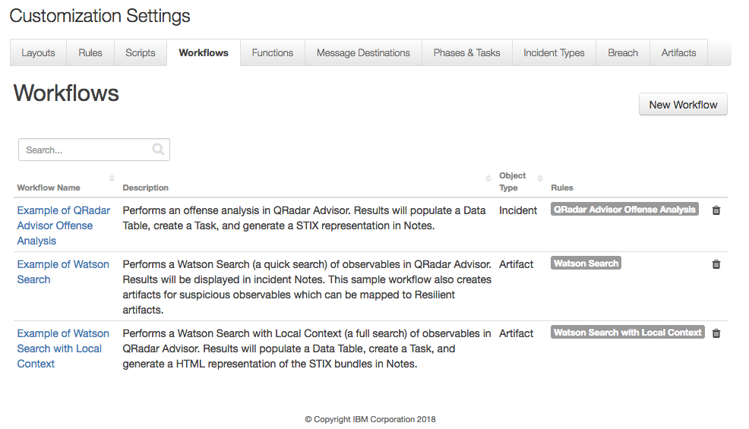

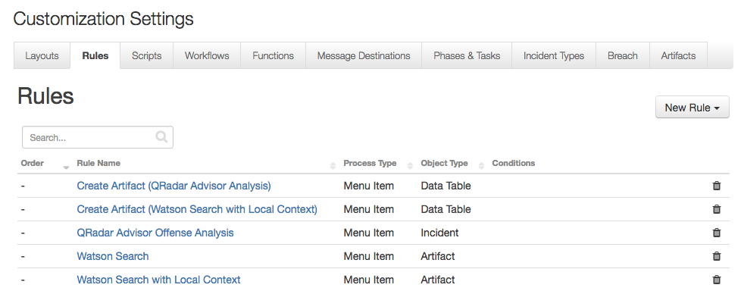

The example workflows shown above demonstrate how to use the functions included in the integration package, as explained below.

Example of Watson Search with Local Context

This example workflow invokes the function “Watson Search with Local Context”. The function calls the QRadar Advisor REST API to perform a Watson Search with Local Context on an indicator.

To use this example workflow and rule included in the package for this function, the user needs to create an incident and add an artifact. For this function to work, the artifact type must correspond to one indicator type. QRadar Advisor supports searches on the following indicators:

* IP addresses
* Hashes
* Domains
* URLs
* Persons

QRadar Advisor supports three return stages:

* Stage1: feature hunt
* Stage2: cognitive investigation added on top of the result of stage 1
* Stage3: wider feature hunt added on top of the result of stage 2

The user can specify the desired return stage in the pre-process script of the example workflow.

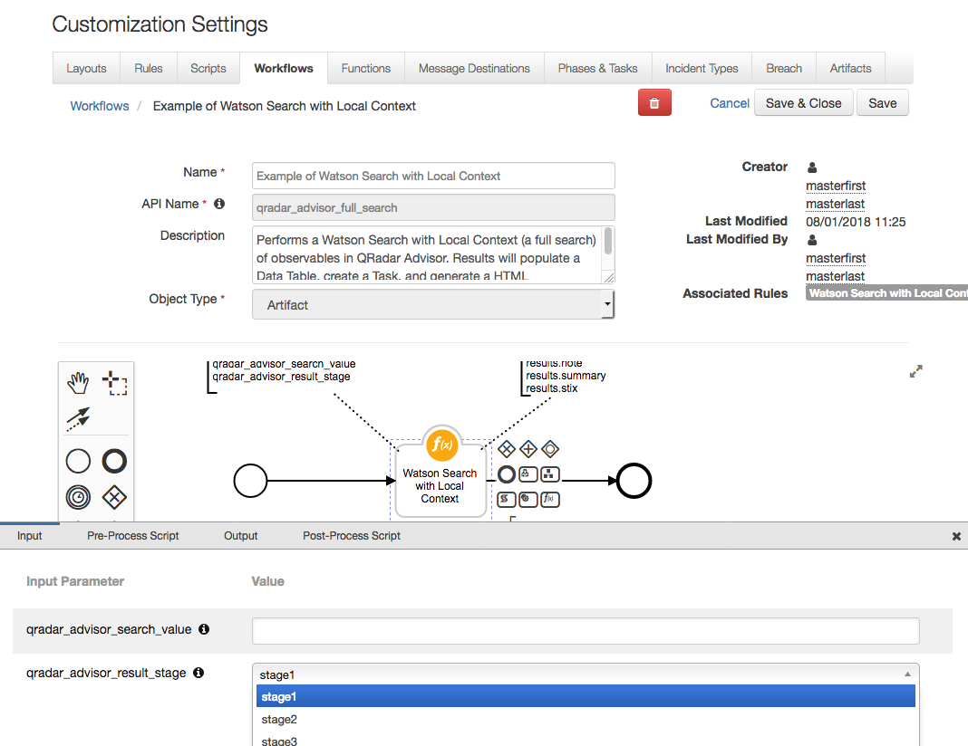

The search REST API of QRadar Advisor returns CTI information in Structured Threat Information Expression (STIX 2.0) format. It is normally a STIX bundle with STIX objects. The function processes the STIX data and performs the following:

* Generates a HTML representation of the STIX data
* Extracts observables from the STIX objects
* Generates a summary from the STIX data

The return data from this function includes the raw STIX data in json dictionary format.

In the post-process script, the HTML representation is used to create a note. The observables are used to populate the custom data table, “Watson Search with Local Context results”, and the summary is used to create a task. Note that the raw STIX data is accessible from the post-process script as results.stix, and can be parsed to create custom code.

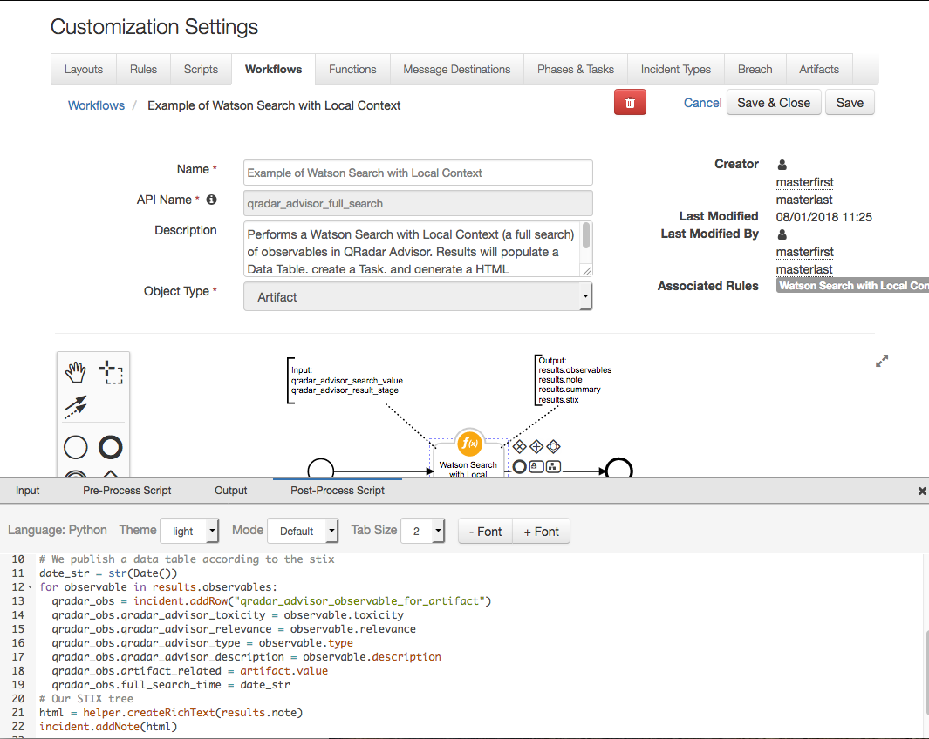

In the following example, a User Account artifact was added to an incident with value “jsmith”. The user can then select Watson Search with Local Context from the artifact menu to search QRadar Advisor for the observable.

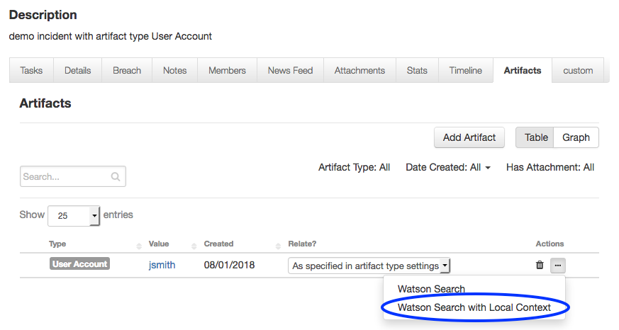

Please note that both Watson Search and Watson Search with Local Context perform queries for information about an indicator. Therefore, only those artifacts that can be mapped into indicators are supported. The types of artifacts that can be searched include:

* DNS Name
* Malware SHA-256 Hash
* Malware SHA-1 Hash
* Malware MD5 Hash
* IP Address
* URL
* User Account

The menu items for Watson Search and Watson Search with Local Context are only shown for the artifact types listed above.

Note that a full search like this could take up to 15 minutes. Once it is completed, the note created for this indicator can be viewed from the Notes tab of this incident.

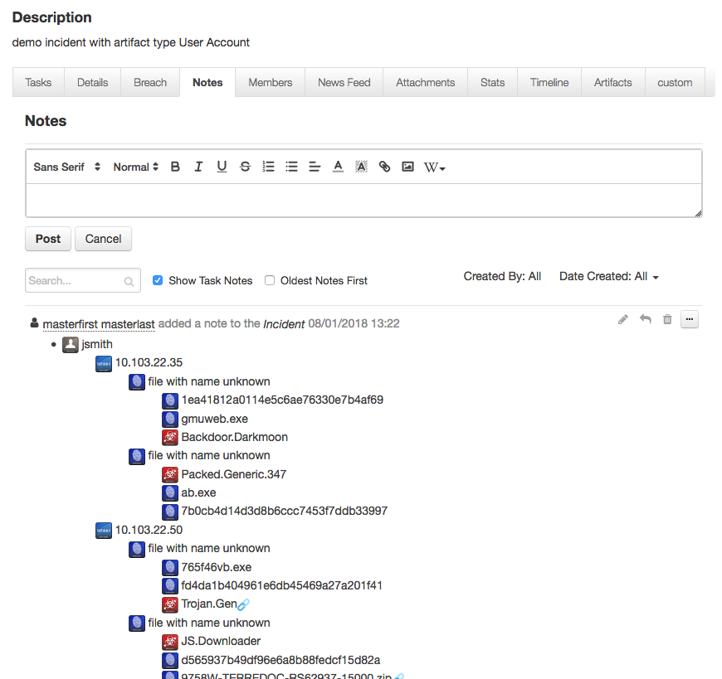

Please note that the icons shown in the above note use external URL referencing to the official site for STIX2 icons (https://raw.githubusercontent.com/freetaxii). Therefore, those icons are shown only if the Resilient platform can access the above website.

Also note that some indicators have a link icon at the end. These indicators are basically placeholders for the other (real) indicators with the same value. Think of them as symbolic links in a folder tree.

The data table can be viewed if the user adds the “Watson Search with Local Context results” data table into one tab of an incident. Note that this package includes a rule, “Create Artifact (Watson Search with Local Context)”, which is added to the “Watson Search with Local Context results” data table. This enables the user to create an artifact based on a selected row from this data table as shown below.

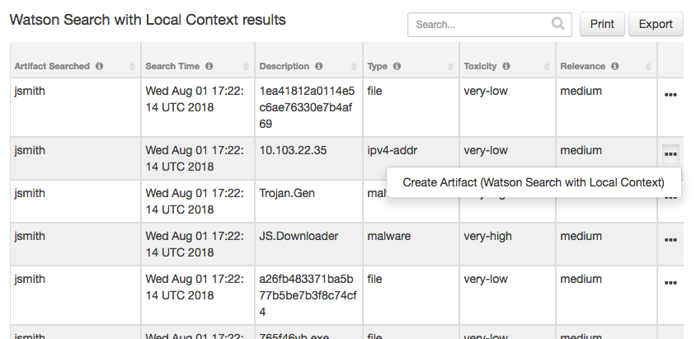

The newly created task can be viewed from the Tasks tab.

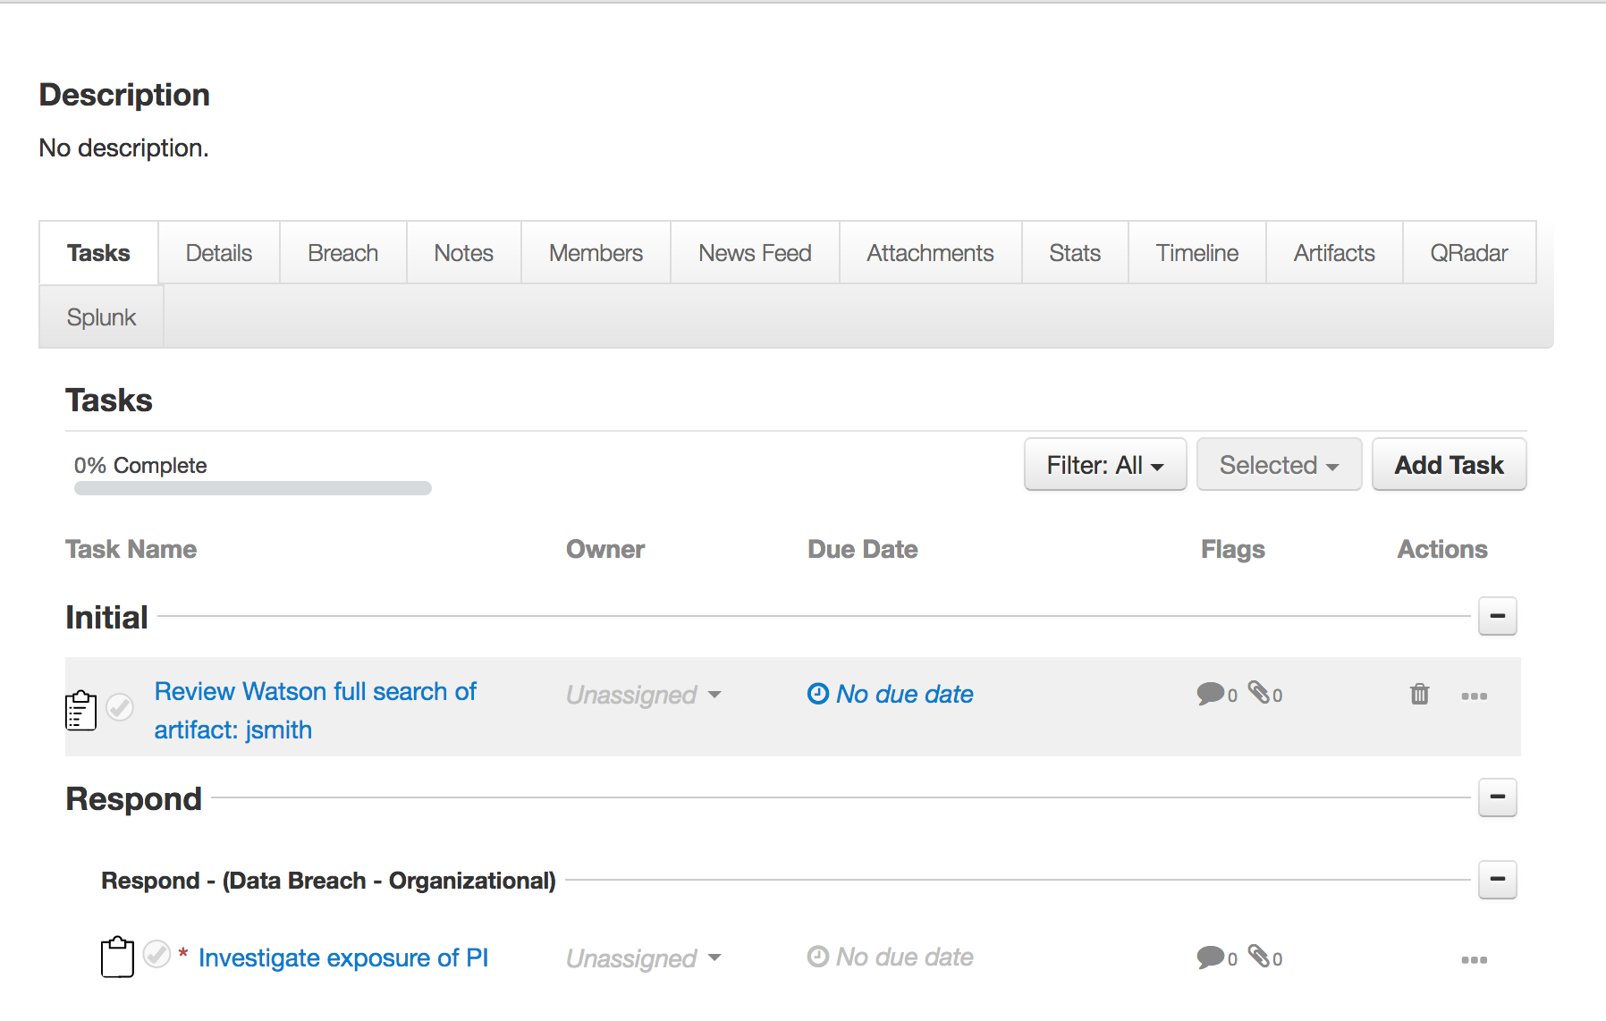

Since Watson Search with Local Context could potentially take a long time to complete depending on the performance of QRadar Advisor, additional configuration settings are available in the app.config file.

|  |  |
| --- | --- |
| **Setting** | **Explanation** |
| full_search_timeout | Timeout in seconds. It is the time the function waits for the result returned from QRadar Advisor. It is optional, and defaulted to 1200 seconds if absent. |
| full_search_period | In seconds. It specifies how often the function checks the search status. It is optional, and defaulted to 5 seconds if absent. |

Example of Watson Search

This example workflow invokes the function “Watson Search”. The function calls the QRadar Advisor REST API to perform a quick search on an indicator.

To use this example workflow, the user creates an incident and then adds an artifact with the desired artifact type as shown in the Watson Search with Local Context function.

The QRadar Advisor REST API for Watson Search returns data in json format. The json dictionary contains two lists, one for suspicious_observables, and the other for other_observables. In the post-process script of this example workflow, the suspicious_observables are mapped to default artifact types, using a dictionary defined there. The user can easily map observables to custom artifacts by modifying the dictionary mapping.

Note the other_observables are not used in this example workflow. If user wants to make use of them, they can be accessed in the post-process script as results.other_observables.

In the following example, a Watson Search on the artifact, “jsmith”, is initiated when selecting Watson Search from the artifact menu.

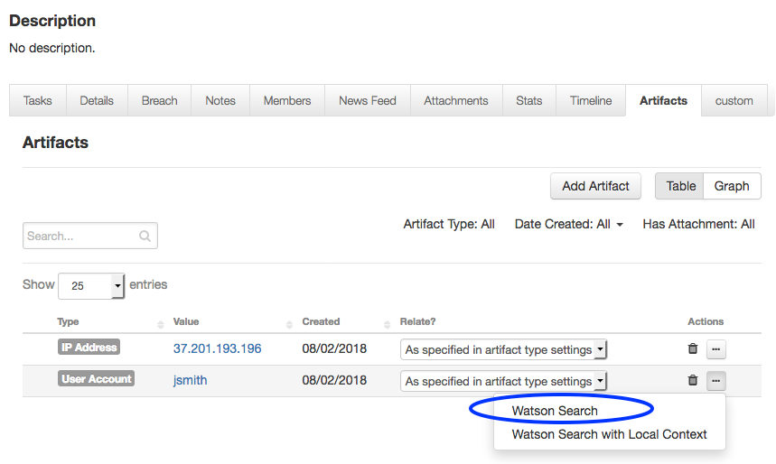

For this example, the Watson Search search of “jsmith” does not return any suspicious observables. As a result, no new artifacts are added. A note was added to the incident to summarize this.

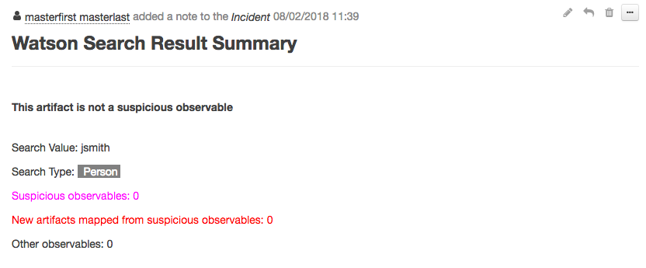

Example of QRadar Advisor Offense Analysis

This example workflow invokes two functions.

|  |  |  |  |
| --- | --- | --- | --- |
| **Function** | **Explanation** | **Package** | **Outputs** |
| QRadar Advisor Offense Analysis | Call QRadar Advisor API   * get the insights of a QRadar Advisor offense. * perform analysis of the offense. | QRadar Advisor integration | * QRadar Advisor Observable data table * Incident note * Task |
| MITRE tactic information | Call the MITRE STIX TAXII server to get information about the MITRE ATTACK tactic(s). | MITRE integration | * MITRE ATTACK of Incident data table * MITRE ATTACK techniques data table |

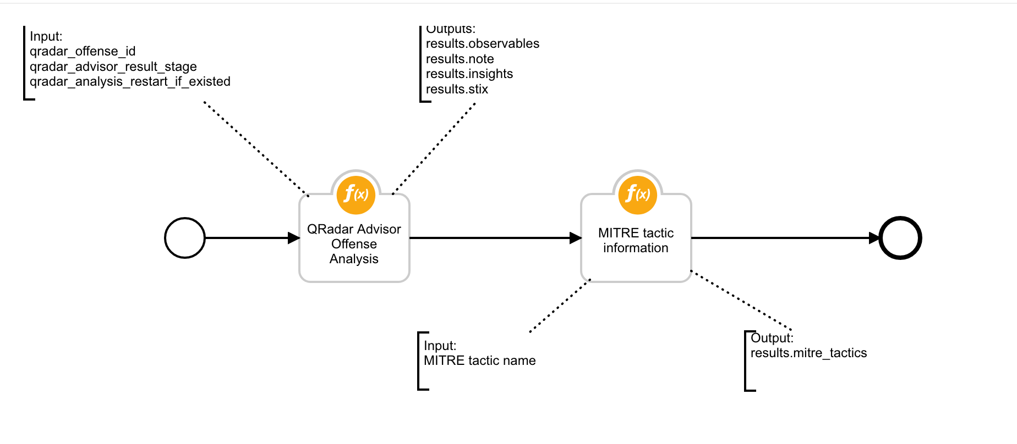

The following data flow diagram shows how these two functions work together with this example workflow.

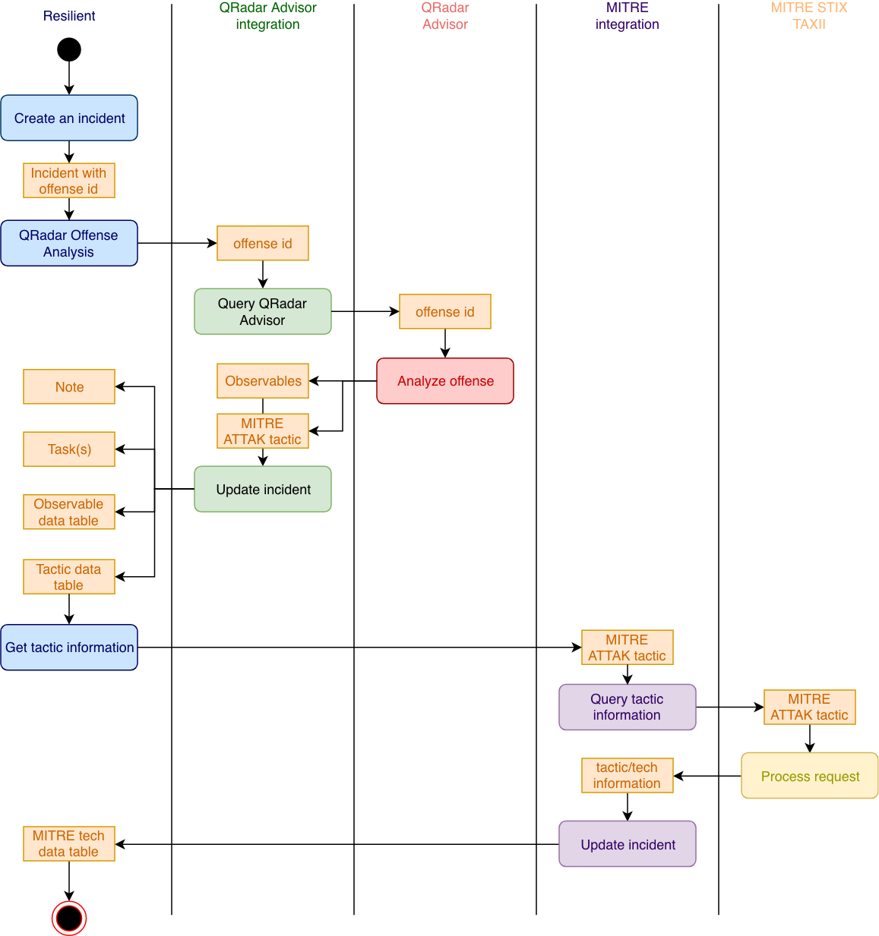

The QRadar Advisor return of insights is in json format, and the result of an analysis is in STIX format.

Similar to the Watson Search with Local Context, the QRadar Advisor Offense Analysis generates a HTML representation of the STIX data. It also extracts observables from the STIX objects.

Just like Watson Search with Local Context, the user can also specify the return stage from the pre-process script of the example workflow.

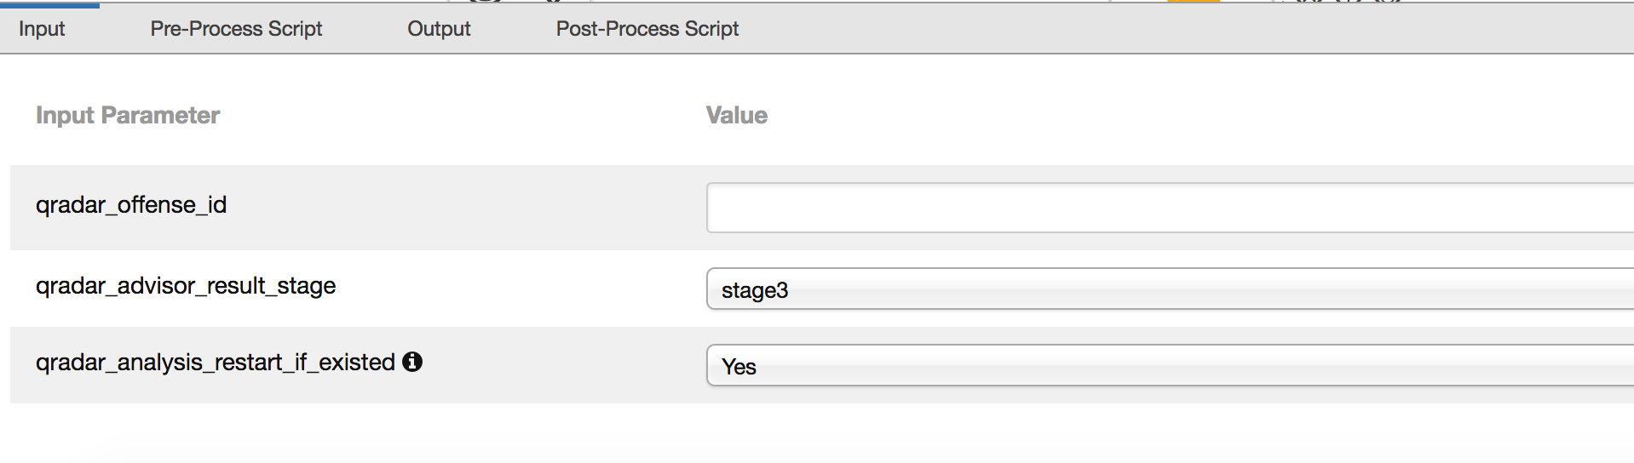

One more setting is qradar_analysis_restart_if_existed. If this flag is set to Yes, the function restarts a new analysis even if a previous result exists for this offense.

In the post-process script of the “QRadar Advisor Offense Analysis”, the HTML representation is used to create a note. The observables are used to populate the “QRadar Advisor analysis results” data table. The insights are used to create a task.

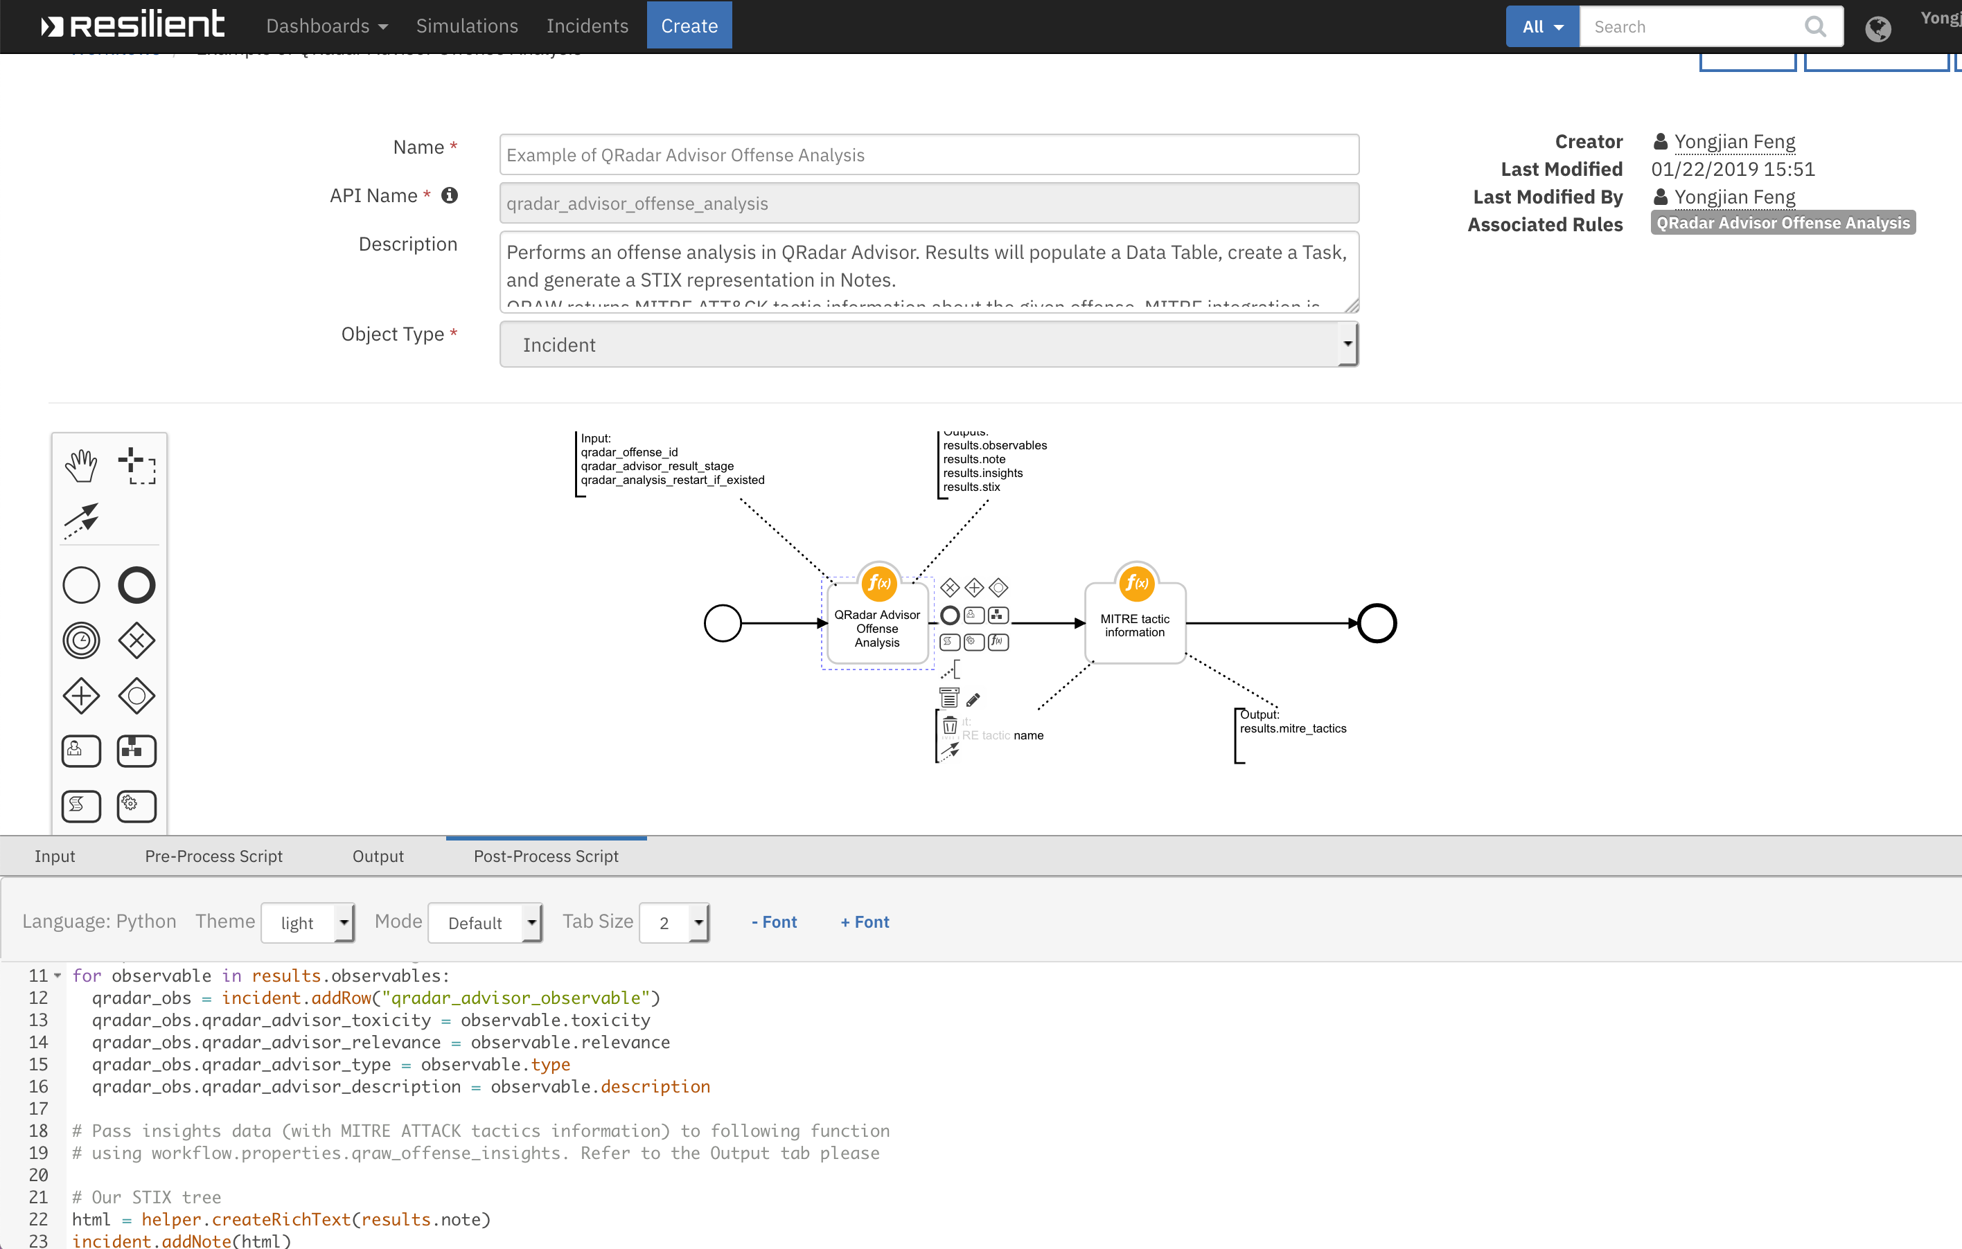

Note the raw STIX data from QRadar Advisor is accessible from the post-process script as results.stix, if the user wants to create custom code to parse the STIX data.

The “QRadar Advisor Offense Analysis” function also returns the MITRE ATTACK tactic(s) associated with this offense. This is passed into the second function “MITRE tactic information”. The second function retrieves technique information related to the given tactic from the MITRE ATTACK STIX TAXII server. The returned information is used to populate the “MITRE ATTACK of offense” data table.

To use the example workflow, a Resilient incident must have a valid QRadar offense ID stored in the qradar_id field. In the following example, the incident is linked to QRadar offense 7.

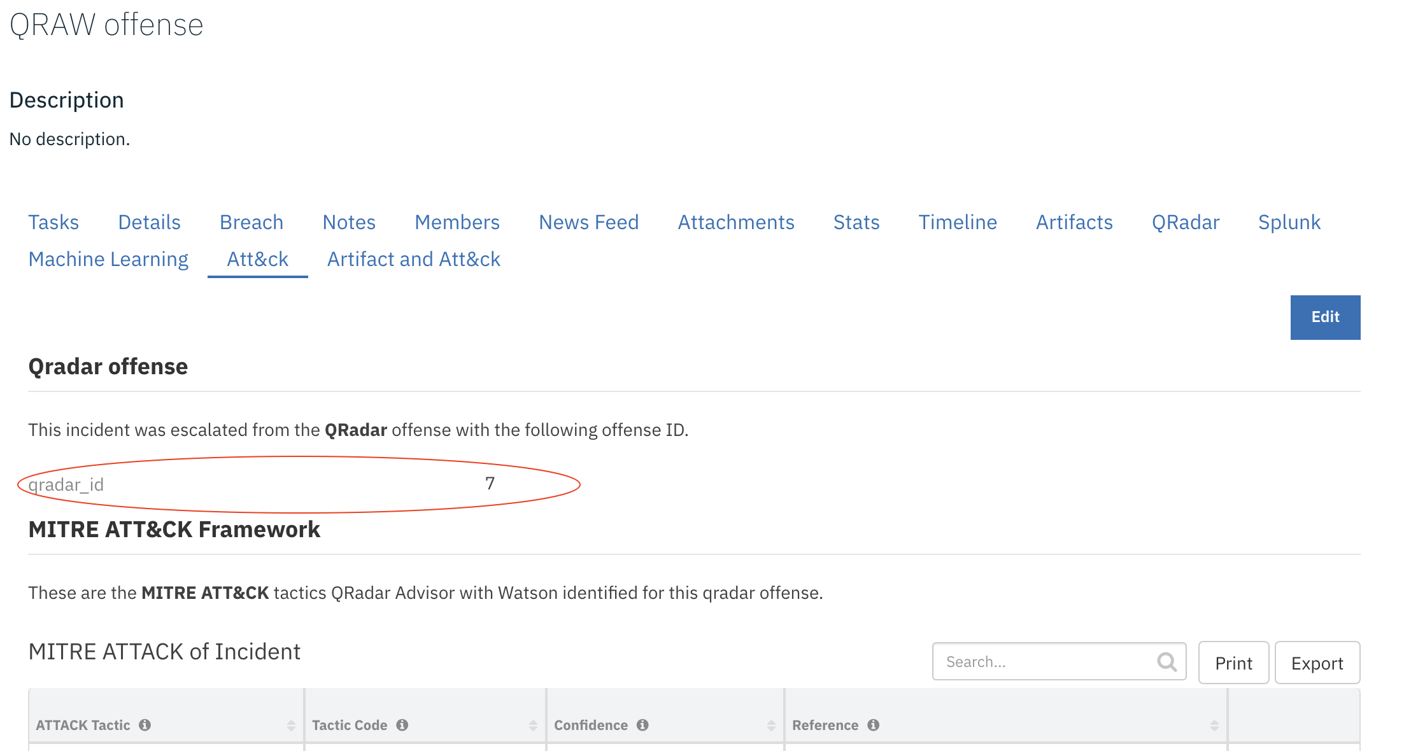

The offense analysis begins upon selection of the rule “QRadar Advisor Offense Analysis” from the Action menu of the incident.

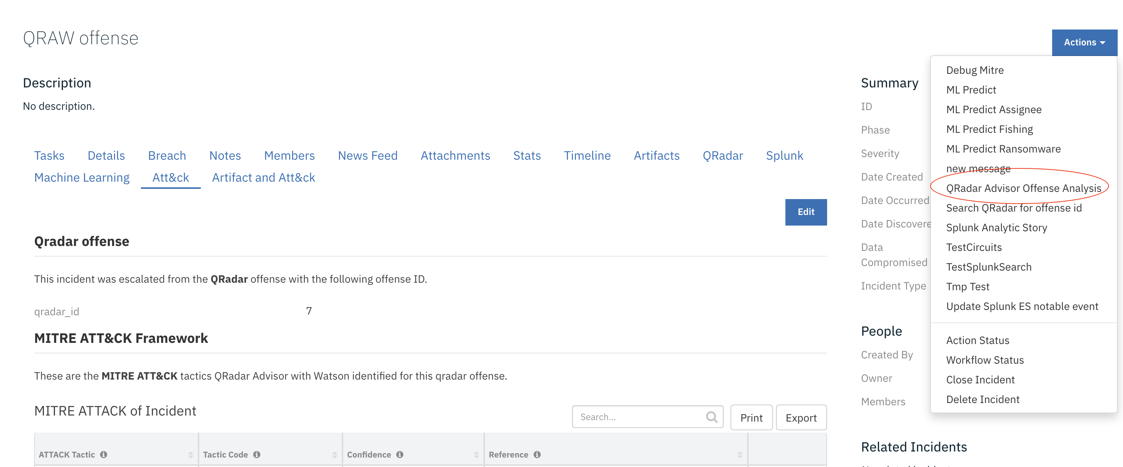

A normal analysis can take up to 20 minutes. Once completed, the HTML representation is shown in the Notes tab.

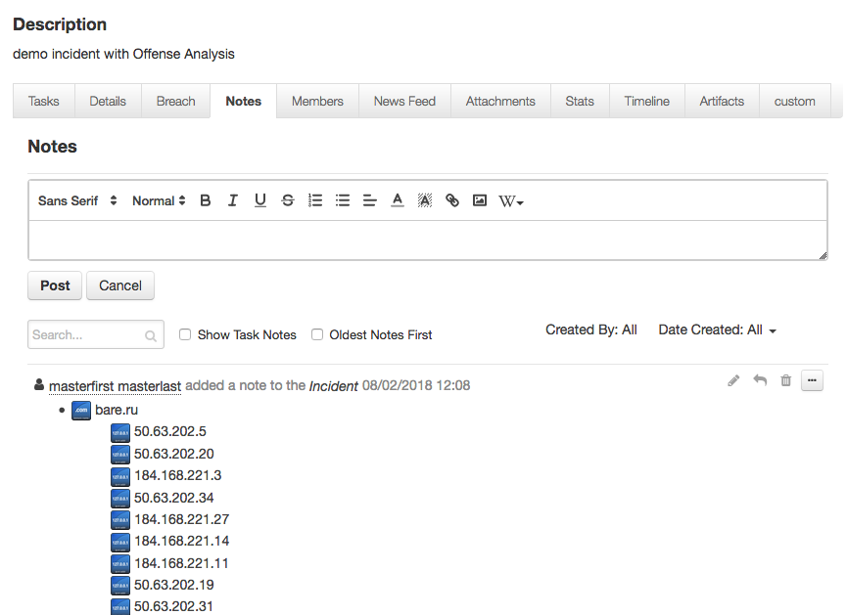

Observables are added to the data table, “QRadar Advisor analysis results”. A menu rule is included for this data table. Users can use it to create a new artifact based on the selected row.

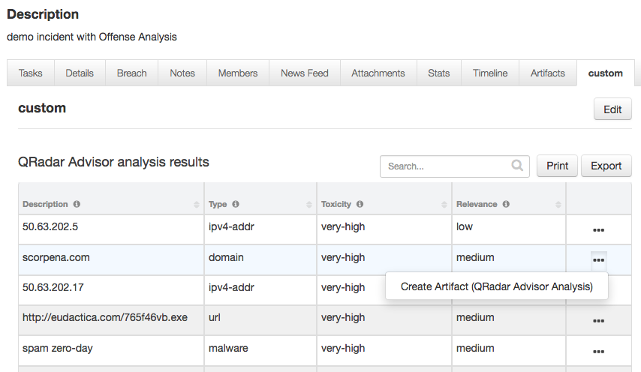

A task is created based on the insights returned from QRadar Advisor. The insights are kept in the instruction of the task.

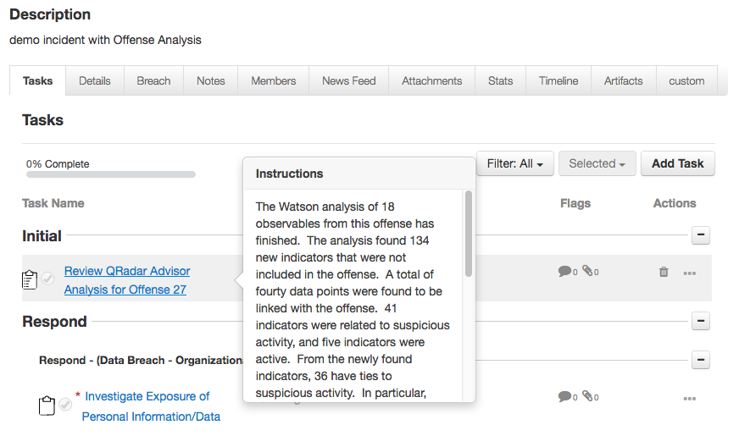

In addition, the “MITRE ATTACK of Incident” data table has been updated with the tactic information. For this particular offense, QRadar Advisor identified that the tactic is “Execution”.

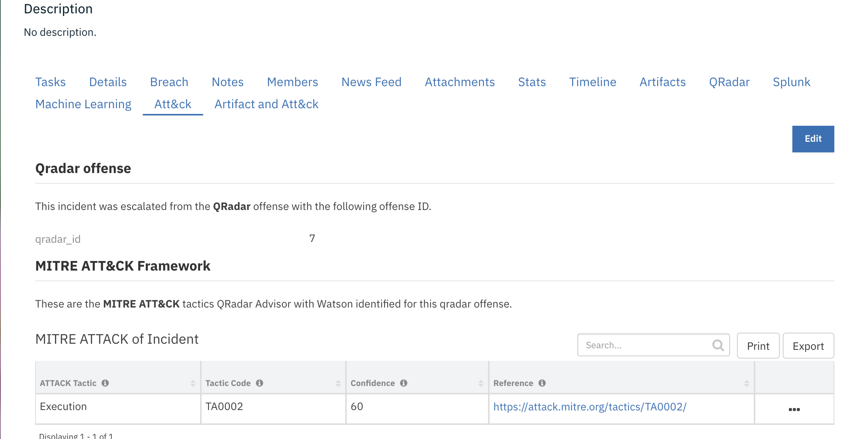

This tactic is used to query information about MITRE techniques. The result is shown in the “MITRE ATTACK techniques” data table.

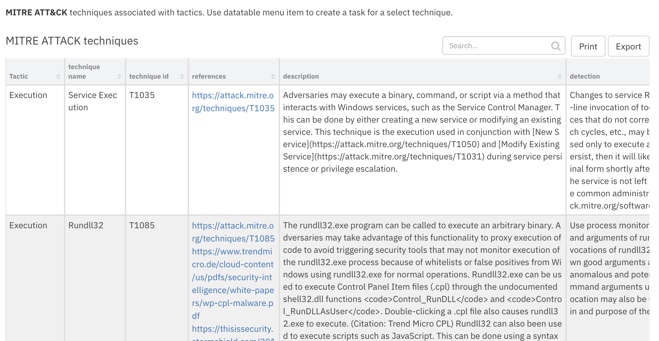

To create a task to further investigate or mitigate a technique, select the “Create Task for Technique” menu item.

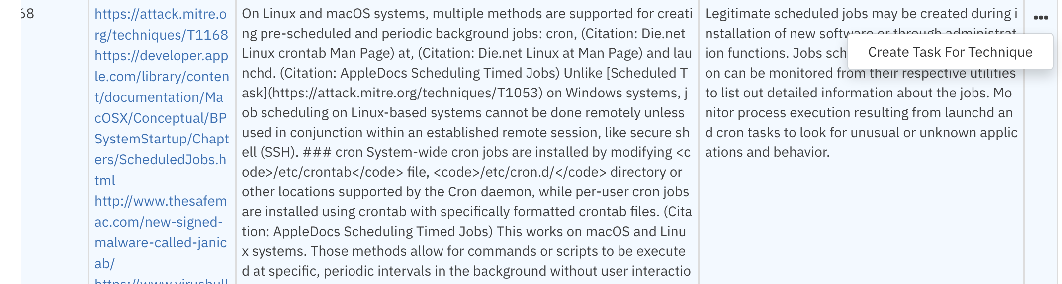

A task is then created with description, detection, and mitigation of the selected technique.

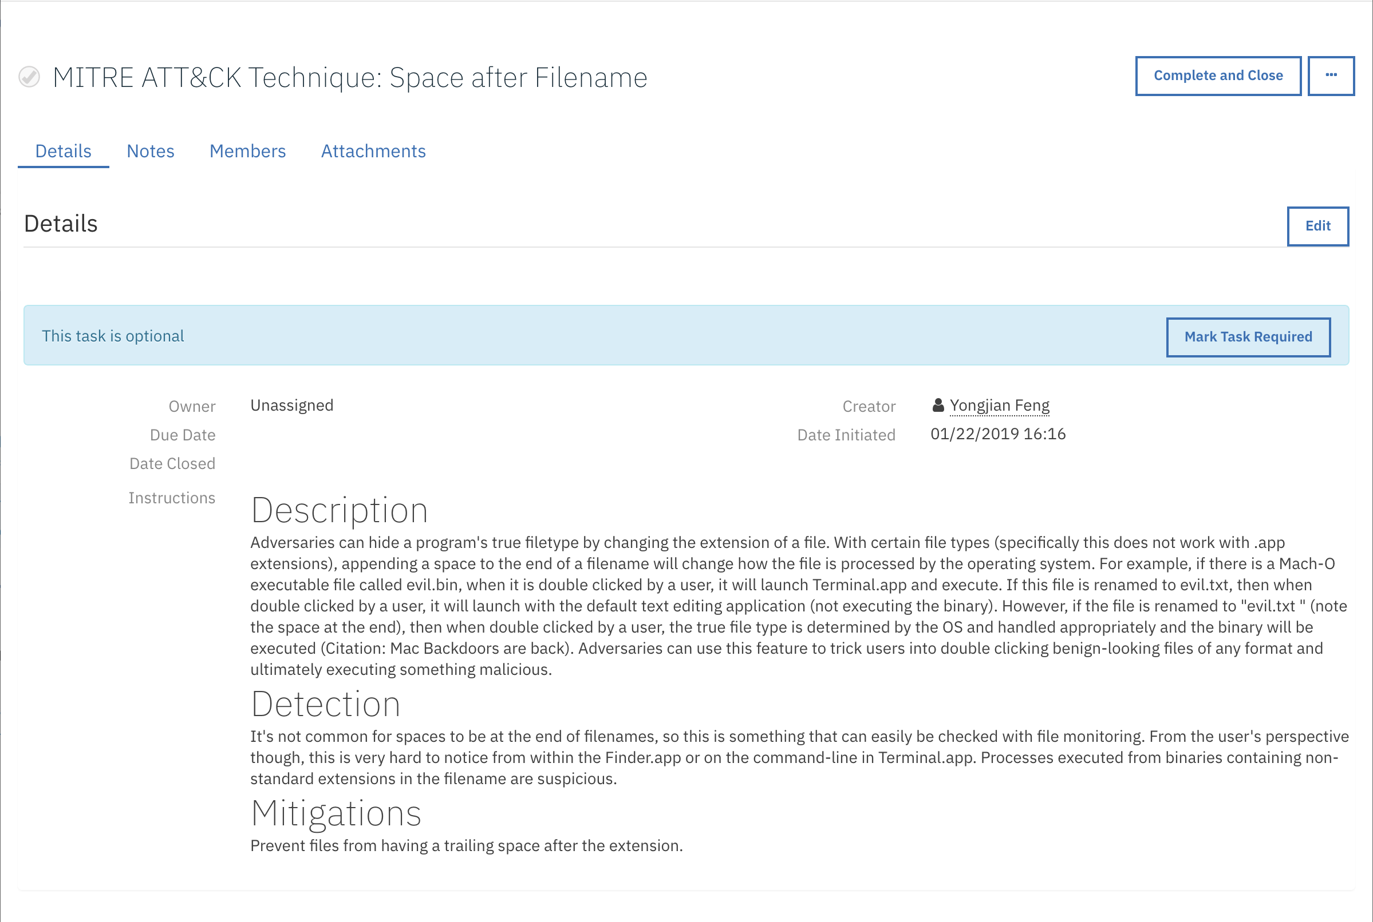

Since an analysis could potentially take a long time to complete depending on the performance of QRadar Advisor, additional configuration settings are available in the app.config file.

|  |  |
| --- | --- |
| **Setting** | **Explanation** |
| offense_analysis_timeout | Timeout in seconds. It is the time the function waits for the result returned from QRadar Advisor. It is optional, and defaults to 1200 seconds if absent. |
| offense_analysis_period | In seconds. It specifies how often the function checks the analysis status. It is optional, and defaults to 5 seconds if absent. |

Example of mapping QRadar rule to tactic

This example workflow invokes two functions from two integration packages.

|  |  |  |  |
| --- | --- | --- | --- |
| **Function** | **Explanation** | **Package** | **Outputs** |
| QRadar Advisor Map Rule | Call the QRadar CAMF API to map a given QRadar rule to a MITRE tactic. | QRadar Advisor integration | MITRE ATTACK of Artifact data table |
| MITRE tactic information | Call the MITRE STIX TAXII server to get information about the MITRE ATTACK tactic(s). | MITRE integration | * MITRE ATTACK of Artifact data table * MITRE ATTACK techniques data table |

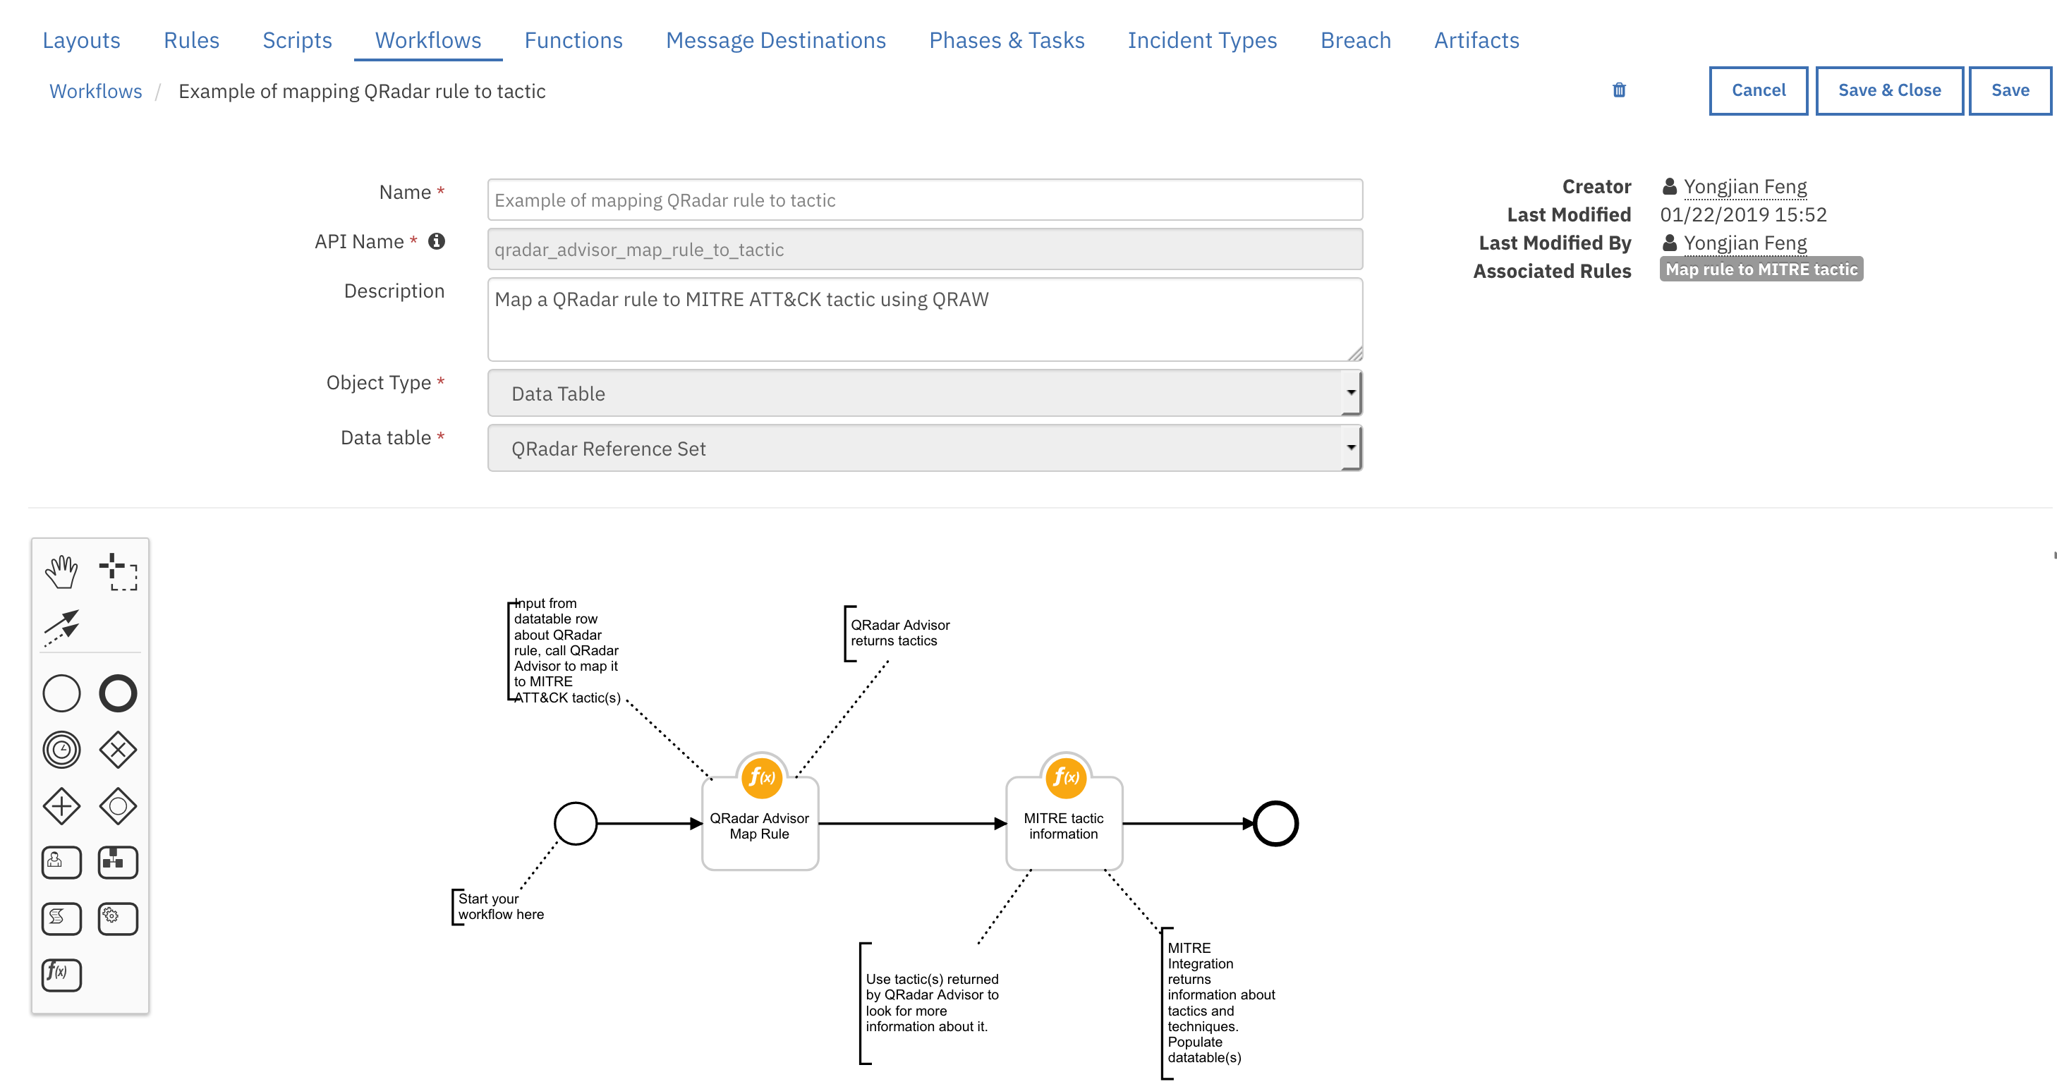

This workflow can work with the “Example of finding QRadar reference set for artifact” workflow from QRadar integration. Basically, this is the use case. First of all, assume that user created QRadar rules to catch suspicious events and populate reference sets on the QRadar side. One example of a QRadar rule is to add the source IP address to a reference set if a local machine contacts an external suspicious site. At the Resilient platform, a given artifact can be traced back to the QRadar reference sets that contains it. In addition, the QRadar rule associated with the reference sets can be obtained. This rule can then be mapped to MITRE ATTACK tactic.

This data flow diagram shows how these two workflows work together for this use case. The dotted line below separates two workflows.

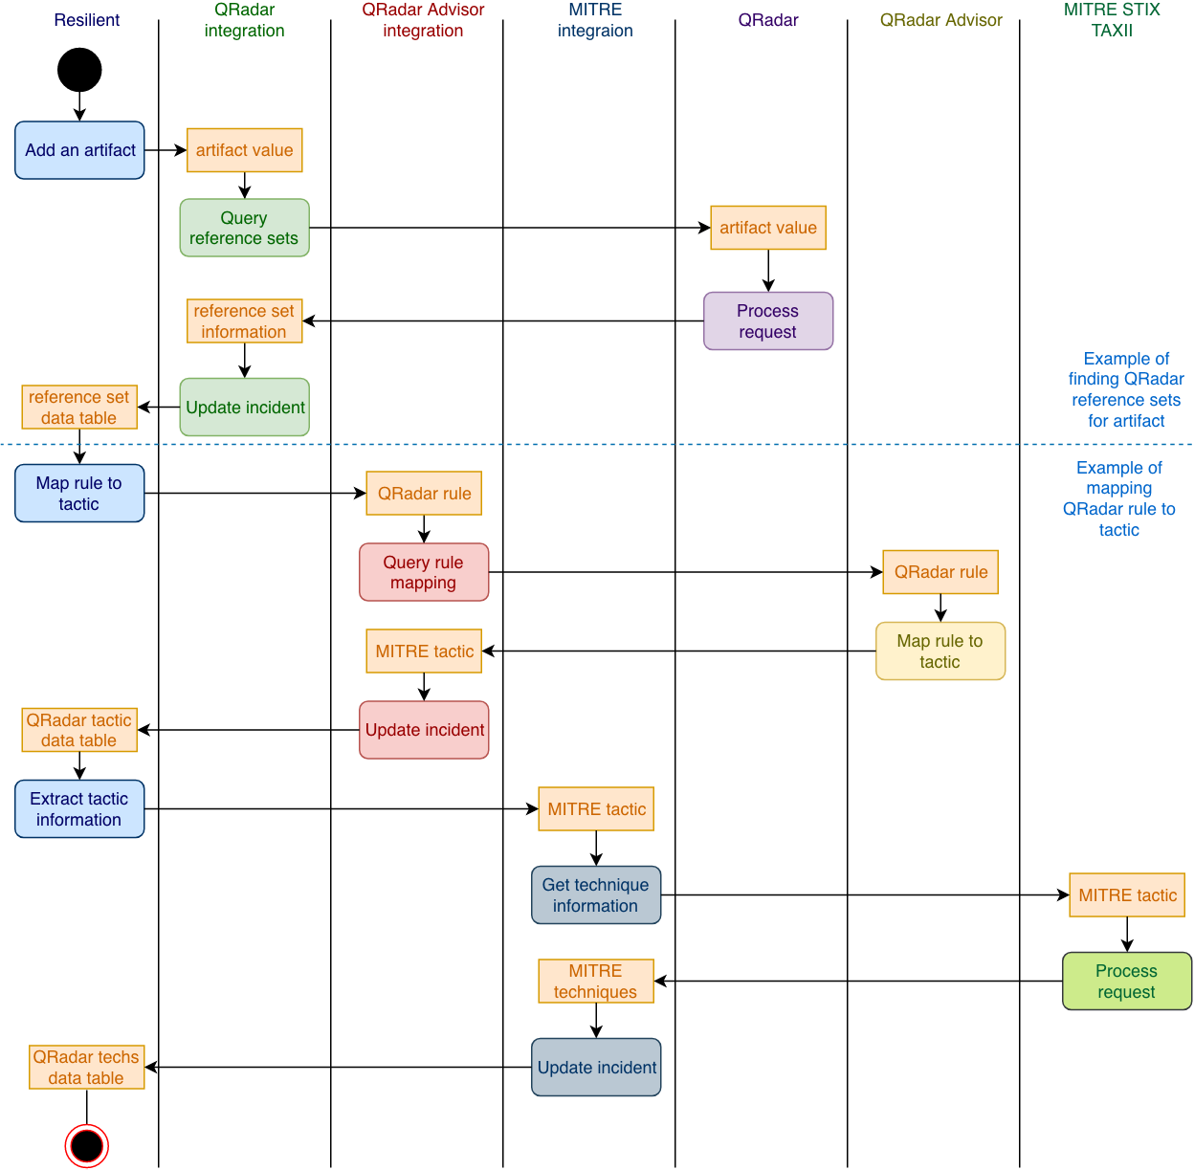

Here is an example of this use case. An IP artifact is added to an incident first. The value is 10.0.15.20. User can select “Find QRadar Reference Sets”.

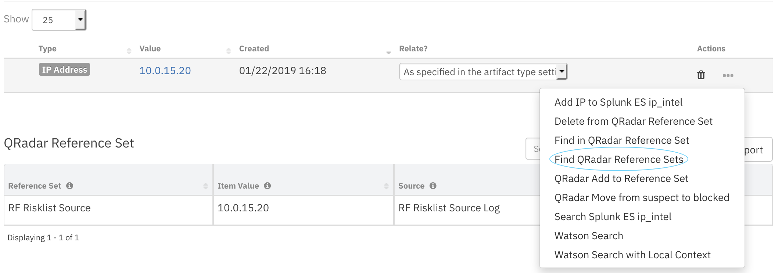

The result is shown in the “QRadar Reference Set” data table. Here we can see that a reference set named “RF Risklist Source” contains an IP address of 10.0.15.20. More importantly, QRadar returns the information about the Source, which is the rule that adds this IP address into this reference set.

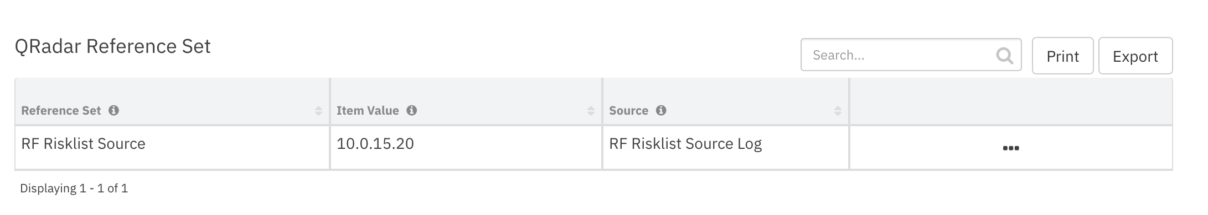

So far, the above is provided by the QRadar integration.

Once the “QRadar Reference Set” data table is populated, we can use the “Example of mapping QRadar rule to tactic”. From the data table above, select “Map rule to MITRE tactic”.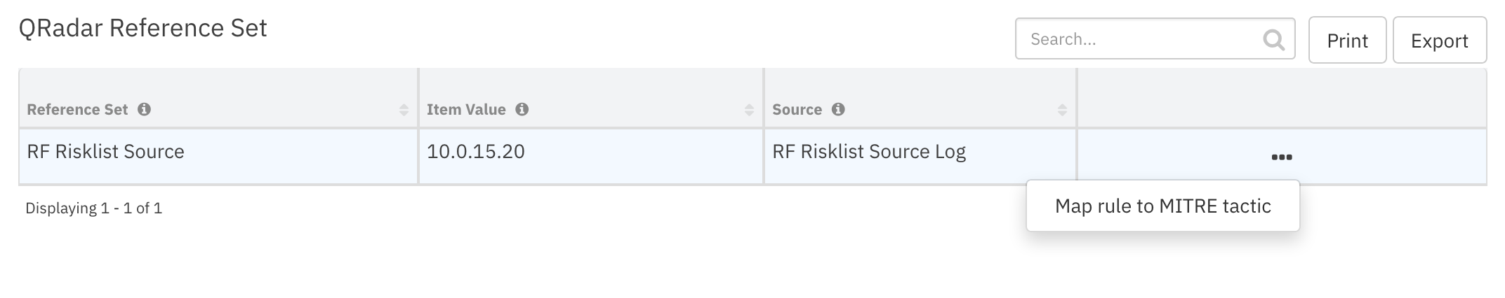

The result is shown in the “MITRE ATTACK of Artifact” data table. QRadar Advisor maps the QRadar rule “RF Risklist Source Log” into MITRE tactic “Initial Access”. The associated MITRE techniques are also shown in the “MITRE ATTACK techniques” data table.

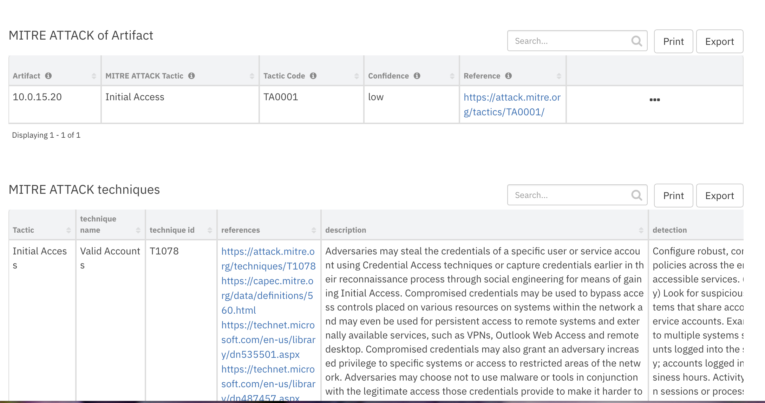

Similar to the workflow example above, a user can further create a task for a selected technique. Please refer to the MITRE integration user guide.

Troubleshooting

There are several ways to verify the successful operation of a function.

* Resilient Action Status

When viewing an incident, use the Actions menu to view Action Status. By default, pending and errors are displayed. Modify the filter for actions to also show Completed actions. Clicking on an action displays additional information on the progress made or what error occurred.

* Resilient Scripting Log

A separate log file is available to review scripting errors. This is useful when issues occur in the pre-processing or post-processing scripts. The default location for this log file is: /var/log/resilient-scripting/resilient-scripting.log.

* Resilient Logs

By default, Resilient logs are retained at /usr/share/co3/logs. The client.log may contain additional information regarding the execution of functions.

* Resilient-Circuits

The log is controlled in the .resilient/app.config file under the section [resilient] and the property logdir. The default file name is app.log. Each function will create progress information. Failures will show up as errors and may contain python trace statements.

Support

For additional support, contact [support@resilientsystems.com](mailto:support@resilientsystems.com).

Including relevant information from the log files will help us resolve your issue.